

SYMBIOSIS INTERNATIONAL (DEEMED UNIVERSITY)
(Established under section 3 of the UGC Act 1956)
Re-accredited by NAAC with “A” Grade

Name of the Student: Sneha Sah PRN: 25070122189
Semester: 3 Year: AY 25-29

ASSIGNMENT No: 7

TITLE: Implement a Java program to demonstrate inheritance and interfaces using suitable real-world examples.

Problem Statement: Implement a Java program to demonstrate inheritance and interfaces using suitable realworld examples.

Theory:

Inheritance is one of the most important features of Object-Oriented Programming (OOP). It allows one class (child class) to inherit the properties and methods of another class (parent class). This helps in reducing duplicate code and makes programs easier to maintain.
Java supports single inheritance using the extends keyword.
Example:
- Shape → Parent Class
- Circle → Child Class
- Rectangle → Child Class
Both Circle and Rectangle inherit common properties from Shape.

Exercise 1.
Create a Shape application where Circle and Rectangle inherit from Shape and calculate area.
Source code:
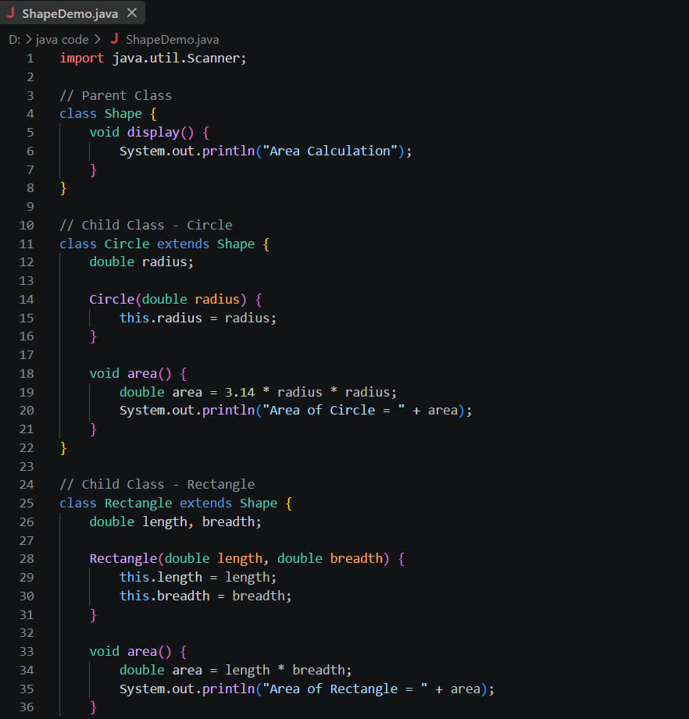
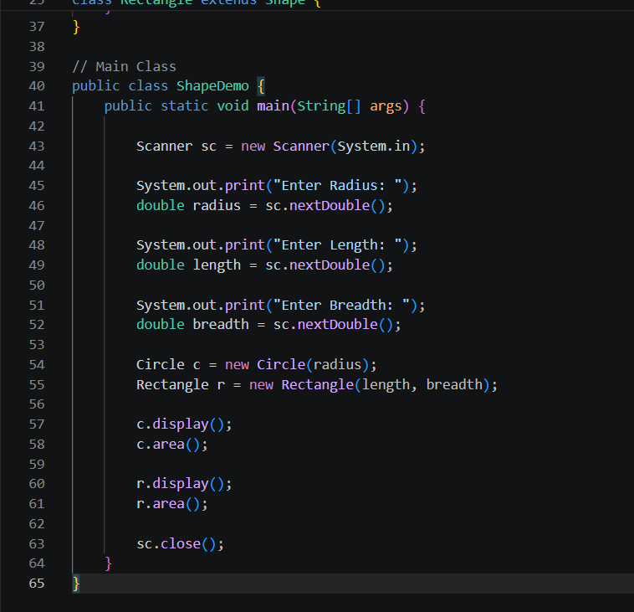
Output:
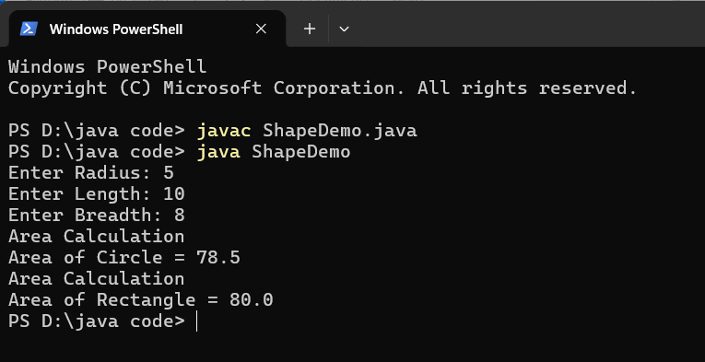

2. Develop a E-Commerce Product System where electronic, clothing, and grocery products inherit common properties and implement product interfaces.

Source code:

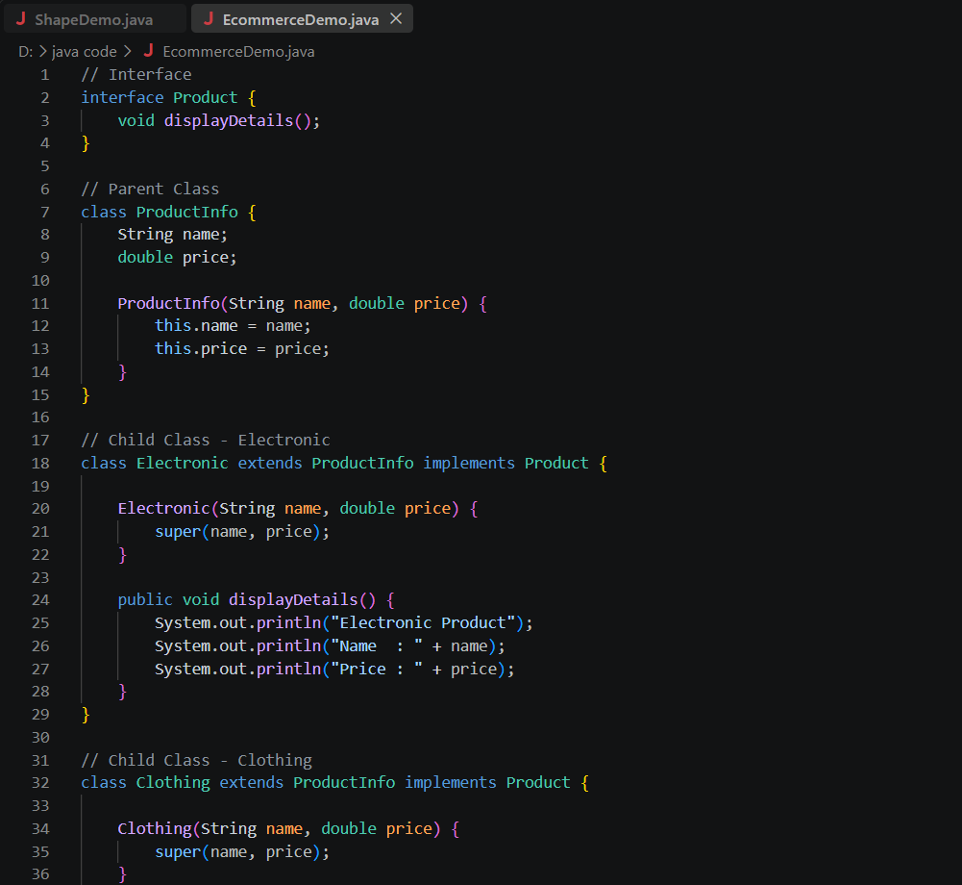

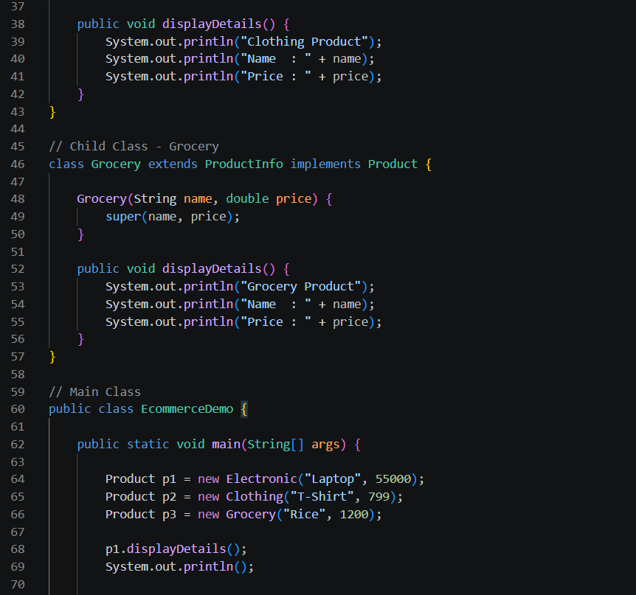


Output:

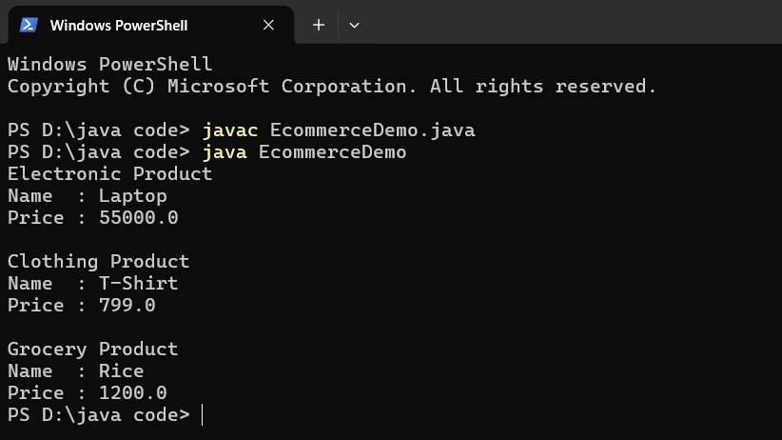

Conclusion

This assignment helped me understand the concepts of Inheritance and Interfaces in Java. I learned how inheritance allows child classes to reuse the properties and methods of a parent class, reducing code duplication and improving code reusability. I also learned how interfaces provide abstraction by defining common methods that different classes can implement in their own way. Through the Shape and E-Commerce Product System examples, I gained practical knowledge of object-oriented programming concepts such as inheritance, abstraction, polymorphism, and modular programming.

